**PROOF OF CONCEPT OR POC**

**ON**

**WALMART DATA ANALYSIS**

**BY-OMBIR**

**BECHELOR OF COMPUTER APPLICATION**

**WITH**

**BIG DATA ANALYTICS WITH IBM**

**SUBMITTED TO-MS. GURPREET KAUR**



**LOVELY PROFESSIONAL UNIVERSITY**

**PHAGWARA**

POC#: Walmart Data Analysis

Public DATASET available at below website <https://www.kaggle.com/datasets/varsharam/walmart-sales-dataset-of-45stores>

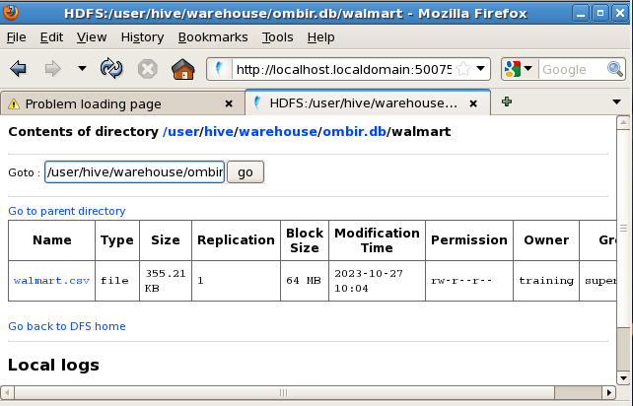

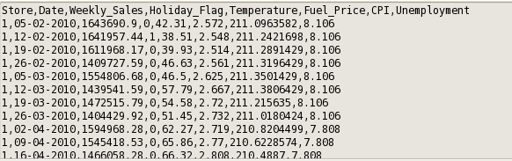

About the Data and Datatype: -

Store a 2-digit String

Weekly sales 9-digit string

Holiday flag 1-digit string

Temperature 4-digit String

Fuel price 4-digit String

Cpi 7-digit String

Unemployment 4-digit String

PROBLEM STATEMENT: -

1. Find the top 10 Store record
2. Find the top 10 CPI rate
3. Find the top 10 Weekly sales
4. Find the top 10 holidays
5. Find the top 10 Fuel price
6. Find the top 10 Temperature

Problem statement with solution using HIVE my database name is OMBIR My table name is Walmart

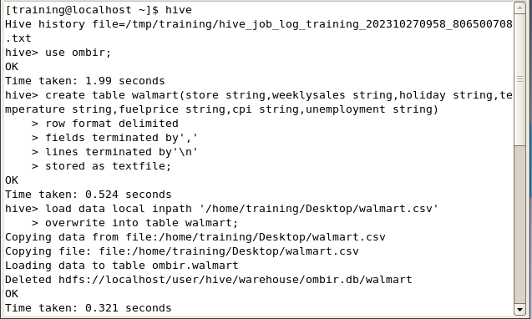

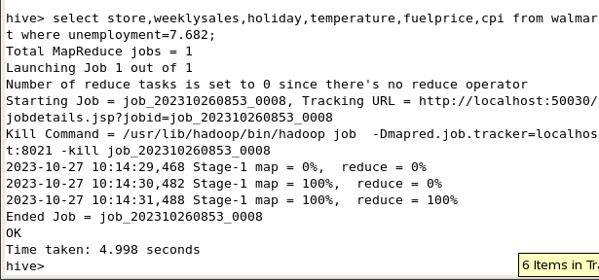

1st Problem is: -

Find the top 10 Stores records

This is my command is

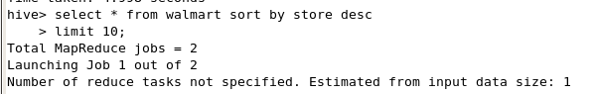

Solution: -

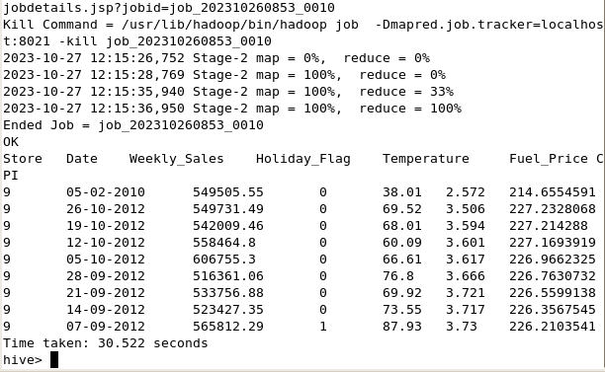

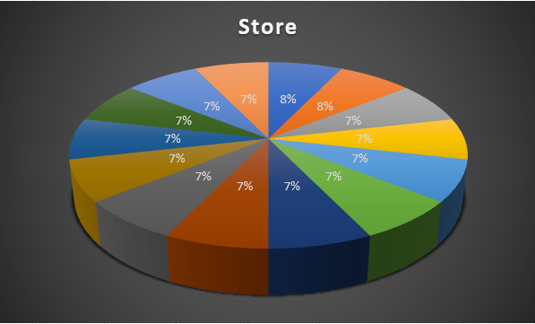

2nd Problem is: -

Find the 10 CPI rate

Command: -

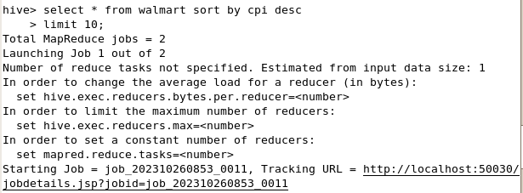

Solution: -

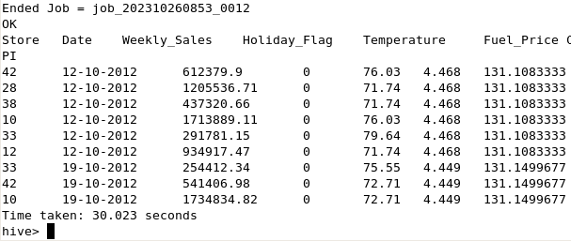

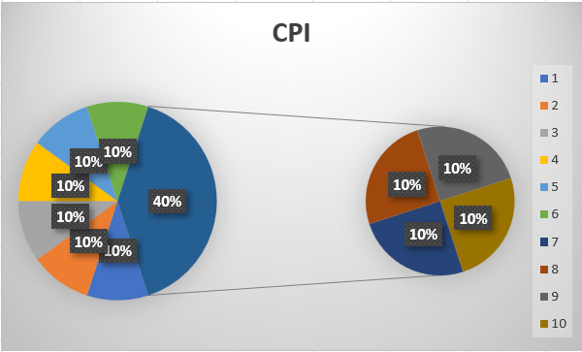

3rd Problem is: -

Find the 10 Weekly Sales rate

Command: -

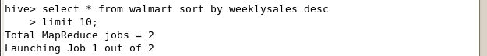

Solution: -

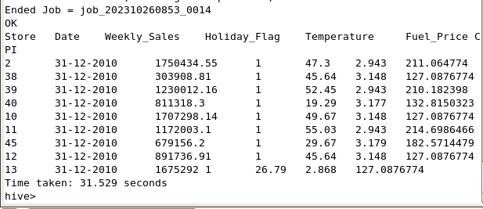

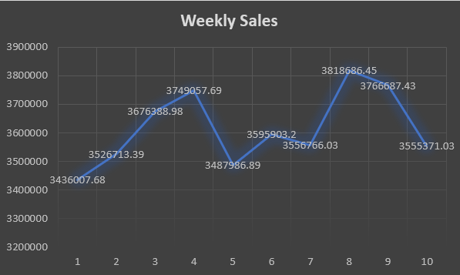

4th Problem is: -

Find the 10 Holidays Day: -

Command: -

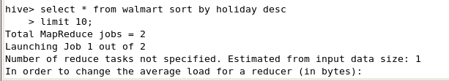

Solution: -

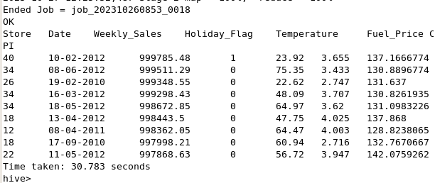

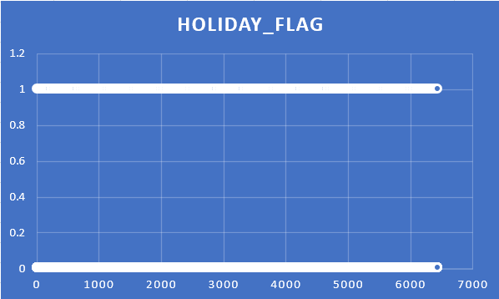

5th Problem is: -

Find the 10 Fuel Price rate: -

Command: -

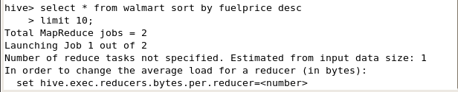

Solution: -

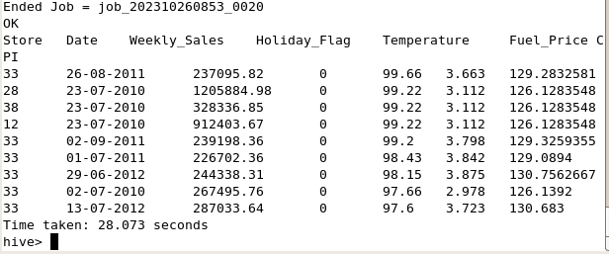

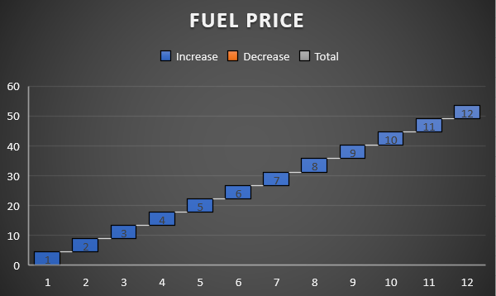

6th Find the 10 Temperature records: -

Command: -

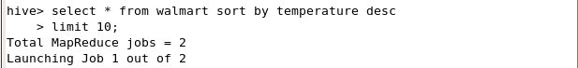

Solution: -

